**Analysis Housing Prices in**

**Metropolitan Areas**

**of India**

**1.Introuction**

**Overview**

Housing prices surge 7% across top eight metros; Kolkata the unlikely topper

|  |  |  |
| --- | --- | --- |
| **City** | **Average Price Q2 2023(₹/sq ft)** | **Y-o-Y Change** |
| Chennai | 7,653 | 3% |
| Delhi NCR | 8,652 | 3% |
| Hyderabad | 10,530 | 1% |
| Kolkata | 7,315 | 1% |

**Purpose:**

Prediction house prices are expected to help people who plan to buy a house so they can know the price range in the future, then they can plan their finance well. In addition, house price predictions are also beneficial for property investors to know the trend of housing prices in a certain location.

**2. Problem Definition & Design Thinking**

The clear definition of the product is required to compare the products sold at different locations

(Burger and Van Rensburg, 2008; Gupta and Das, 2008; Das et al., 2010). Hence, the paper

concentrates on the price of residential properties which has been taken from the National

Housing Bank (NHB) in the form of index. Unlike the South African house prices that have been

captured for various categories of houses (Burger and Van Rensburg, 2008; Das et al., 2010),

this study rely on simple house price index created only for the residential houses. The NHB

pilot study was conducted primarily in five large cities (Delhi, Mumbai, Kolkata, Bengaluru and

Bhopal) covering various regions of India.

*Empathy Map*

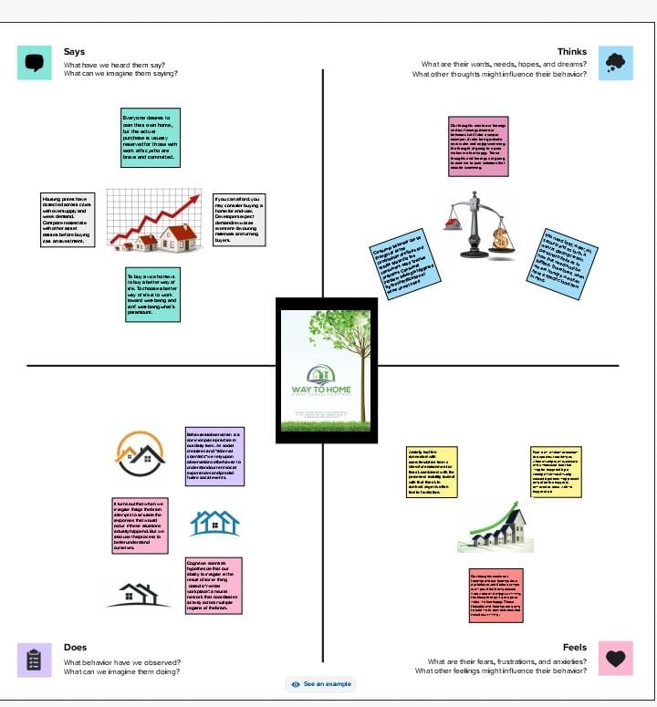

Ideation & Brainstorming Map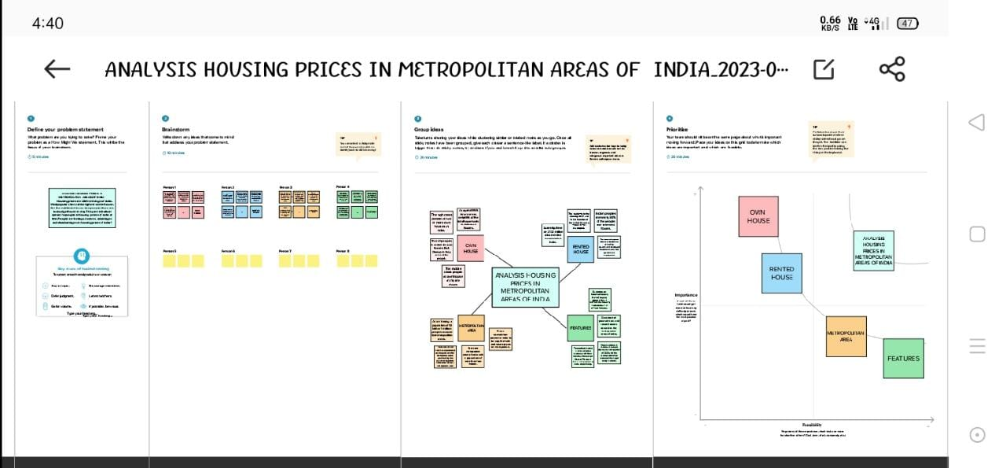3. **Result:**

*Dashboard*

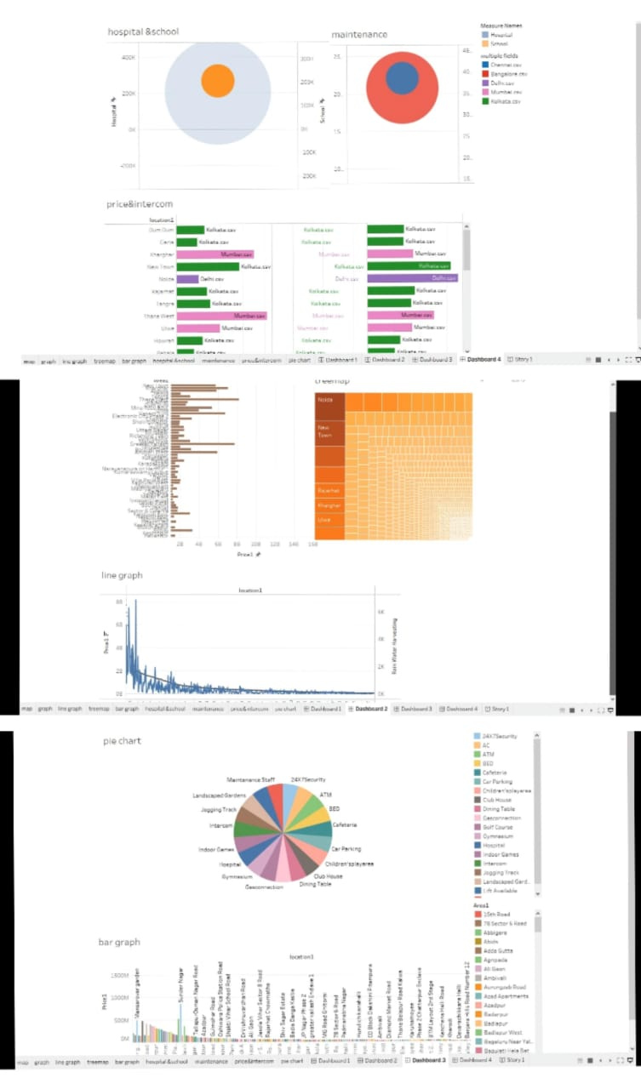*Story*

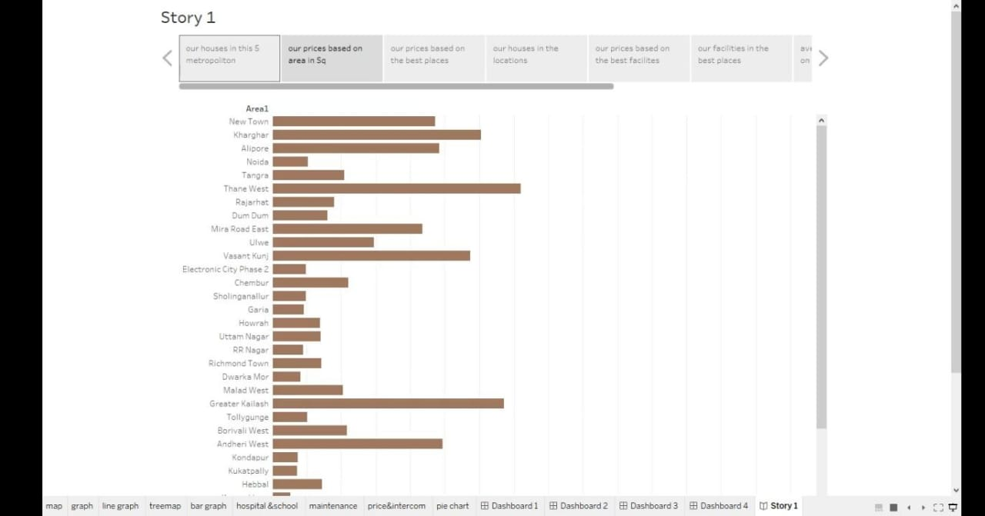

**4.Advantages**

House price prediction can help the developer determine the selling price of a house and can help the customer to arrange the right time to purchase a house. There are three factors that influence the price of a house which include physical conditions, concept and location.

As a resident of the metropolitan area you are located closer to the city. In the city you have better opportunities for jobs with higher paying salaries. You also have better access to public transportation. There is generally a more diverse population and lifestyle.

Security, convenience, low maintenance and extra features such as a pool, make apartment living attractive to buyers and tenants alike

**Disadvantages**

The disadvantages of owning a home mostly fall into the category of permanence, with a dash of financial uncertainty. Buying a new house costs money, and a lot of that money comes out of your pocket at the time of the purchase. Later, there are no guarantees that home prices will rise.

Modern buildings use materials like asbestos, lead, etc., which are very hazardous and are not recyclable or disposable, these materials harm the environment and promote global warming and pollution.

The problems of metropolitan areas in India start mainly due to overcrowding, bad living conditions, lack of basic facilities, high unemployment, extreme poverty and lack of social infrastructure. The government needs to provide jobs, education, healthcare and infrastructure to solve urban poverty in India.

**5. Application**

House price prediction can help the developer determine the selling price of a house and can help the customer to arrange the right time to purchase a house. The values of X and Y variables are training datasets for the model representation of linear regression.

**6. conclusion**

This paper analyzes whether the Law of One Price (LOOP) holds in the housing

market of fifteen metropolitan areas in India, namely Delhi, Mumbai, Bengaluru,

Kolkata, Chennai, Jaipur, Lucknow, Hyderabad, Pune, Surat, Ahmedabad, Patna,

Faridabad, Kochi and Bhopal. We test the existence of LOOP using the Im, Pesaran

and Shin (2003) panel unit root test based on quarterly data on residential property

prices covering the period of 2007Q1 to 2011Q4 of the Indian housing market. Based

on the criterion of price convergence, house prices in the 15 metropolitan cities do not

converge to the LOOP. This implies that the housing markets in the different areas

operate as segmented independent local markets. Therefore, house prices in one

location in India cannot impose a competitive constraint on house prices in other

location, and as such a home owner can freely set the price of his house.

**7. Future scope**

"India's real estate sector is expected to expand to USD 5.8 trillion or USD 5,833 billion by 2047. This estimated real estate output value will contribute 15.5 per cent to the total economic output in 2047 from an existing share of 7.3 per cent," Naredco-Knight Frank said in a statement.